My Activities

1. My Activities – Page Overview
The My Activities section serves as the main interface for users to execute their assigned tasks within MOS. It offers a centralized and organized view of all activities attributed to each user, consolidating assignments from various workflows. This unified perspective ensures that users can efficiently manage and track their responsibilities.
Access to activities within My Activities is determined dynamically at runtime. The visibility of content, as well as the range of actions that a user can perform, depends on several factors:
- User’s Assigned Roles (Permissions): The permissions granted to a user govern which actions and information they can access.
- RACI Role for Each Workflow Step: The user’s specific RACI (Responsible, Accountable, Consulted, Informed) designation for individual workflow steps further influences what they can see and do.
- Approval Responsibilities: Any approval duties that have been assigned to the user within workflows also impact on the activities and options available to them.
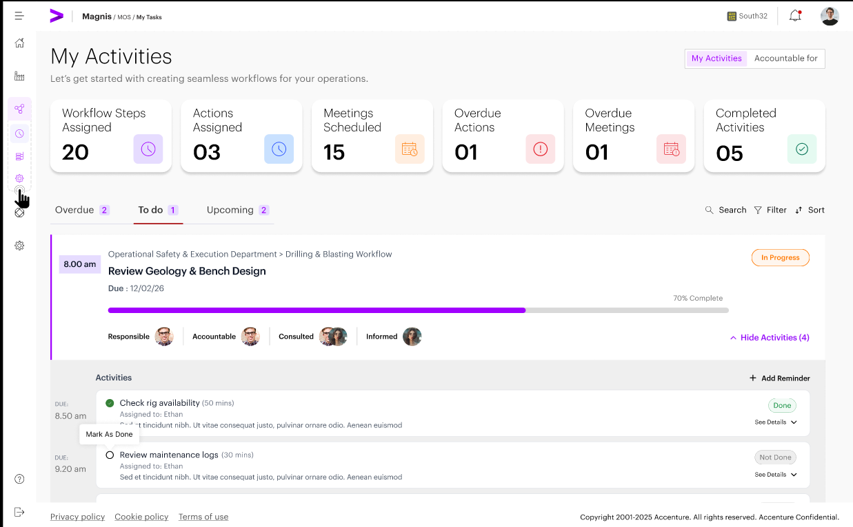

2. Activity Visibility Rules
Activity visibility within My Activities is governed by a combination of role permissions and RACI assignments at the workflow step level. These rules ensure that users have access only to the information and actions relevant to their assigned responsibilities, supporting both security and efficient task management.

2.1 Responsible (R) Visibility.
Users assigned as Responsible (R) at the workflow step level shall:
- See all workflow steps where they are listed as Responsible
- See only those activities within the step that are explicitly assigned to them
If multiple Responsible users exist for a step:
- All Responsible users shall see the step
- Only the user assigned to an activity shall see that activity
- Responsible users without assigned activities shall see the step but no activities under it

2.2 Accountable (A) Visibility
Users assigned as Accountable (A) for a workflow step shall:
- See all workflow steps where they are Accountable
- See all activities under those steps, regardless of assignee
- Access the Accountable For dashboard for monitoring execution

2.3 Consulted (C) and Informed (I) Visibility
Users assigned as Consulted (C) or Informed (I):
- Shall not see workflow steps or activities (except meeting) in My Activities
- Shall see meeting activities only if they are participants
- Shall have no execution or approval capabilities
Note: VD Screens to be updated

2.4 Approver Visibility
- Users assigned as Approvers shall see approval activities that are currently pending their action in My Activities.
- For each pending approval, the Approver’s view shall present a three-level context so the Approver can understand where the approval sits and what is being approved:
  - Workflow Step – the step card/row that contains the approval.
  - Approval Activity – the approval activity card that requires the Approver’s decision.
- Linked Action Activity – the specific action/task activity that the approval is associated to Selecting (opening) the Approval Activity shall display the approval context and controls, including:
  - Approval decision actions: Approve and Reject (Reject requires a mandatory comment).
  - Workflow identification: Workflow Name and Workflow Step Name.
  - Linked Action visibility: The name of the linked action activity and a way to open/view its details for verification before approving
(read-only view of the action’s key fields such as title, description, due date/time, assignee, attachments/inputs where applicable).
  - Requester/originator: The user who initiated or submitted the activity for approval.

3. Accountable For – Dashboard Behavior (MVP)
- The Accountable For dashboard provides users assigned as Accountable (A) with visibility and monitoring capabilities over workflow execution for the steps they are accountable for.
- The dashboard is not role-based and is not a static supervisor view. Access to this dashboard is dynamically enabled at runtime based on RACI assignments within workflows.
Access and Eligibility Rules
Eligibility Criteria
- The Accountable For dashboard shall be visible only to users assigned as Accountable (A) for one or more workflow steps
- If a user is not assigned as Accountable (A) in any active workflow, the Accountable For dashboard shall not be displayed, and the tab selector on the top right shall not be shown.
Role Independence
- Access to the Accountable For dashboard is independent of user roles
- Assignment to a Supervisor or Worker role is not required
- RACI assignment alone determines access
The Accountable For tab shall display:
- Summary statistics of accountable items
- Workflow steps for which the user is Accountable
- Expand/collapse hierarchy:
  - Workflow → Step → Activities
- Completion status and progress
- Exception indicators:
  - Overdue: Indicates the number of activities overdue. Additionally, users are presented with two tabs for further information.
    - Overdue Actions – Displays overdue task-based activities
    - Overdue Meetings – Displays overdue meeting-based activities
    - Overdue Action activities shall retain the standard action/task icon.
Overdue Meeting activities shall display a meeting/calendar icon, visually distinct from actions.
- For steps containing approval activities, the dashboard shall show:
  - Pending approvals
  - Approved activities
  - Rejected approvals with status indication
- Rejection Impact Visibility
  - Rejected approvals shall be clearly flagged
  - Dependent steps shall be shown as blocked until re-approval is completed
Restrictions and Non-Capabilities
The Accountable For dashboard shall not allow users to:
- Execute or complete activities
- Approve activities unless explicitly assigned as an approver
- Edit workflows or steps
- Override execution or approval outcomes

4. My Actions – Personal Actions
The My Actions tab lets users easily create and manage their own personal tasks that aren’t part of any workflow. This helps users keep track of their individual work and manage their to-do list.

4.1 Capabilities
Within the My Actions tab, users are provided with several essential capabilities to help manage their individual tasks. Specifically, users can:
- Create personal actions to track tasks that are not part of any predefined workflow.
- Assign a personal action to another system user. Upon assignment, the personal action shall be removed from the creator’s personal actions list and added to the assigned user’s personal actions list.
- Edit personal actions, allowing updates and modifications as circumstances change.
- Delete personal actions to remove tasks that are no longer relevant or required.
- Mark personal actions as completed once the associated task has been fulfilled.

4.2 Ownership and Scope
- Personal actions are exclusively owned by the user who created them.
- These actions remain private and are visible only to their owner, ensuring confidentiality and individual task management.
- Personal actions operate independently and do not affect workflow progress, dependencies, or compliance metrics within the broader system.
Note : Updated VD Screens will be placed soon

5. Summary Metrics Section
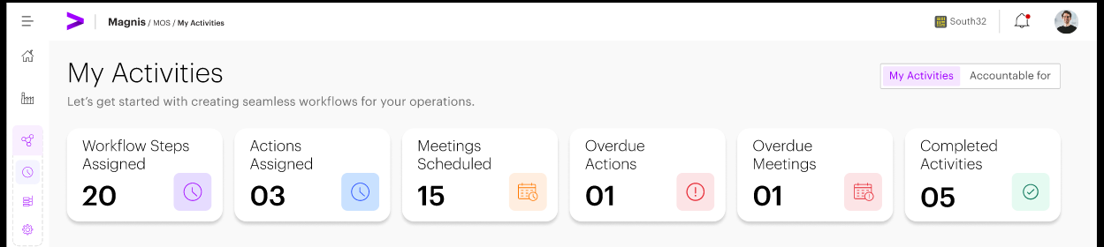
The top section of the My Activities page displays summary level activity metrics to provide users with immediate operational awareness. Each metric represents a distinct aspect of activity status to help users quickly assess their current responsibilities and progress.
- Workflow Steps To Do…d: The total number of workflow steps currently in progress/ assigned to the user, including all states and statuses.
- Actions To Do…d: Activities that are scheduled for future execution and are not yet actionable, either due to future start times or dependencies that have not been met.
- Meetings Scheduled: This status shows number of meetings scheduled. It helps users track official meetings and improves visibility for participants, making it easier to organize tasks and prepare for discussions or decisions.
- Overdue Activities: Indicates the number of activities pending completion. Additionally, users are presented with two tabs for further information.
  - Overdue Actions – Displays overdue task-based activities
  - Overdue Meetings – Displays overdue meeting-based activities
  - Overdue Action activities shall retain the standard action/task icon.
Overdue Meeting activities shall display a meeting/calendar icon, visually distinct from actions.

- Completed Activities: Displays the number of completed activities.
- Approval Count - TBD
These metrics update dynamically based on activity status and are intended for informational and situational awareness purposes only. They do not serve as navigation controls.

6. Activity Filter Bar
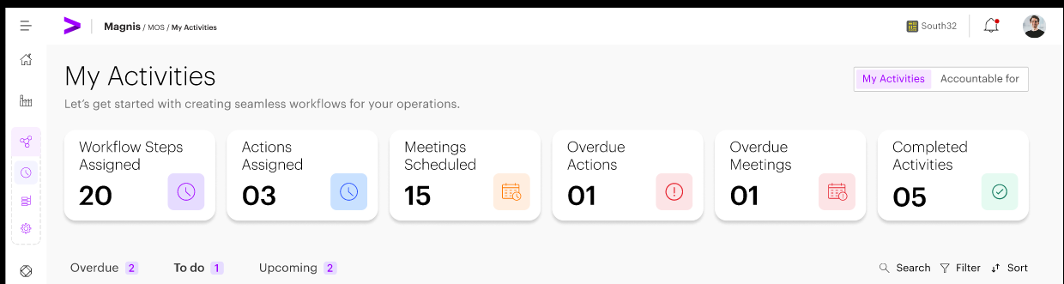
Activity filtering is enabled through a horizontal filter bar positioned below the summary metrics.
The filter bar allows users to toggle between the following activity states:
- Overdue – Activities that have passed their scheduled due time
- To Do – Active and unlocked activities that are ready for execution
- Upcoming – Activities that are not yet actionable due to future start times or unmet dependencies
- Completed – Activities that have been completed by the user.
- My Actions - Activities that are personally assigned / created by the user for working on the activities. This will also display personal actions assigned by other users to that individual user
In addition to state-based filtering, the filter bar provides:
- Search Functionality: Users can quickly locate specific activities by entering search terms related to the activity’s name or its context. This allows for rapid identification and access to relevant tasks within the workflow.
- Filter Options: The Filter functionality allows users to systematically narrow down data sets based on predefined criteria, helping them focus only on what is relevant to their role, responsibility, and timeframe.
  - Key Objectives of Filter
    - Filters allow users to limit results based on attributes such as:
    - Timeframe (This Week, This Month, Upcoming)
    - Workflow frequency (Daily, Weekly, Monthly, Shift)

- Search Controls: The Search functionality enables users to instantly locate specific items without manually scanning long lists or dashboards.
  - Key Objectives of Search
    - Allows users to quickly find workflows, steps, activities, or meetings by searching on attributes such as:
    - Workflow name
    - Step name
    - Activity or meeting title
    - Department name
    - Owner / Responsible / Accountable user
This horizontal filter mechanism replaces the need for a persistent left-hand navigation pane and ensures a focused execution experience.

7. Step-wise Activity Display
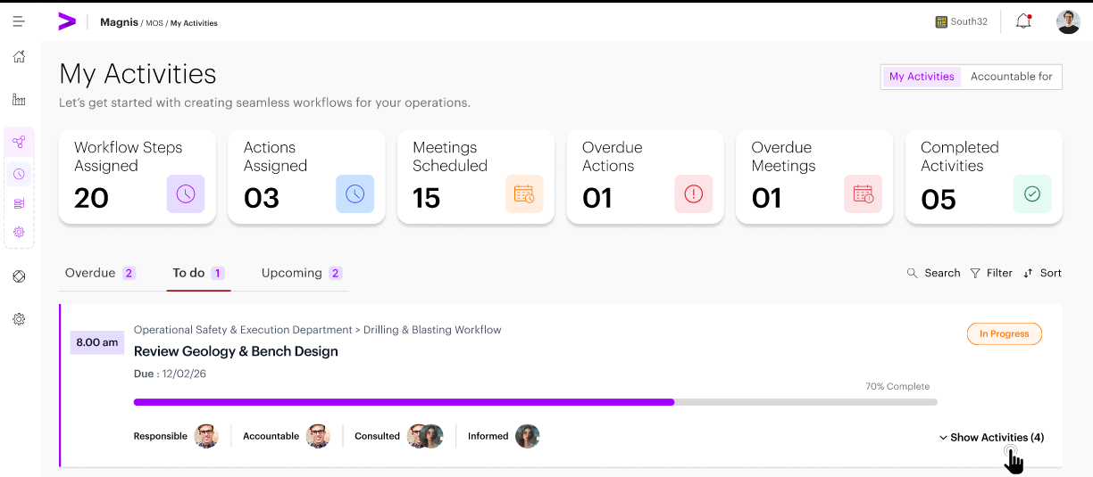
Activities are displayed grouped under their respective workflow steps in the main execution area.
Each workflow step is presented as a collapsible step card containing:
- Step Start Time: Displays the scheduled start time for the workflow step, allowing users to understand when activities within the step become actionable.
- Step Name and Description: Presents the name and a brief description of the workflow step, providing clarity on the step’s purpose and context within the overall workflow.
- Progress Indicator: Visually represents the completion status of all underlying activities associated with the workflow step, enabling users to quickly assess how much work remains.
- RACI Role Visibility: Identifies the RACI (Responsible, Accountable, Consulted, Informed) roles for the workflow step, making it clear who is responsible, accountable, consulted, or informed for each activity within the step.
Users can expand or collapse workflow steps to view or hide the associated activities.
Inline Activity Cards
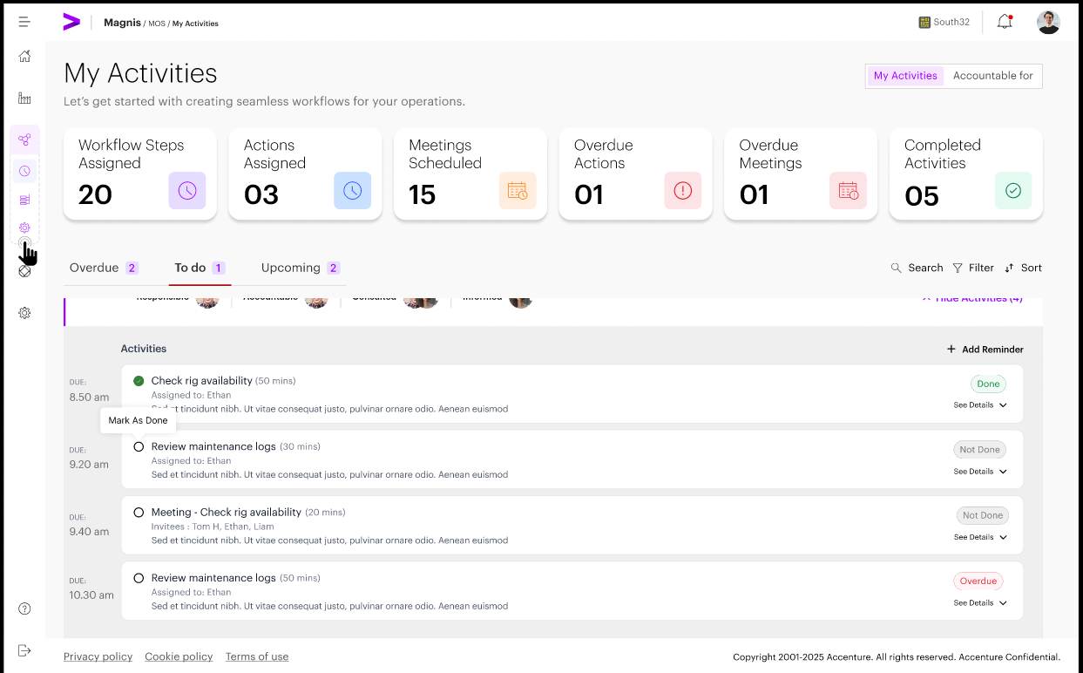
When a workflow step is expanded, its activities are displayed as inline activity cards. Each activity card includes:
- Activity Type: Indicates the nature of the activity, such as Action, Meeting
  - Action: An actionable item assigned to an individual or team that needs completion as part of the workflow.
  - Meeting: Meeting activities represent structured coordination events within a workflow and require additional mandatory metadata. Each meeting activity must capture the following attributes:
    - Location / Place: The designated venue or virtual platform where the meeting will occur.
    - Start Time: The scheduled time at which the meeting is set to begin.
    - Duration: The total length of time allocated for the meeting.
    - 5Ps Framework:
      - Purpose – Objective of the meeting
      - People – Required participants
      - Preparation – Pre-work or inputs required
      - Process – Meeting structure or agenda
      - Payoff – Expected outcome or deliverable
    - Note - A meeting activity cannot be scheduled or published unless all mandatory meeting attributes, including the 5Ps, are completed. Validation errors will prevent workflow publishing until all required information is provided.
  - Approval activity cards shall show:

Field | Description
Approval Activity Entry | The approval appears as a distinct activity item in the My Activities page when the workflow reaches an approval step. It is visible to the approver (Accountable user).
Workflow Name | Displays the name of the workflow to which the approval activity belongs, providing high-level context to the approver.
Workflow Step Name | Shows the workflow step under which the approval activity is configured, indicating the hierarchical position of the approval.
Activity Being Approved | Displays the name of the specific prior activity (from the same step) that is linked to the approval..
Approve Action | Allows the approver to approve the linked activity directly from the approval activity entry.
Reject Action | Allows the approver to reject the approval request. Rejection requires a mandatory comment explaining the reason.
Rejection Comment | Mandatory text input captured when an approval is rejected. This comment is stored as part of approval history.
Approval Status | Displays the current status of the approval activity (e.g., pending, approved, rejected) as part of workflow progress tracking.

- Activity Title and Brief Description: Provides the name of the activity along with a concise overview, helping users quickly understand its purpose and requirements.
- Due Time: Displays the deadline or scheduled time for the activity, enabling users to track time-sensitive actions efficiently.
- Current Status: Activity status shall be displayed Done or Not Done. Where applicable, the system shall display additional state indicators as separate pill badges adjacent to the status pill, including: Overdue and Waiting Dependency.
- Primary Execution Actions: Presents key actions for managing the activity, such as marking it as done, facilitating direct interaction and completion tracking within the workflow step context.
Note : Updated VD Screens will be placed soon

8. Activity Detail & Execution Interaction
Activity details are accessed and executed inline within the workflow step context. When a user interacts with an activity card, the following information and actions are available inline or through an expandable view:
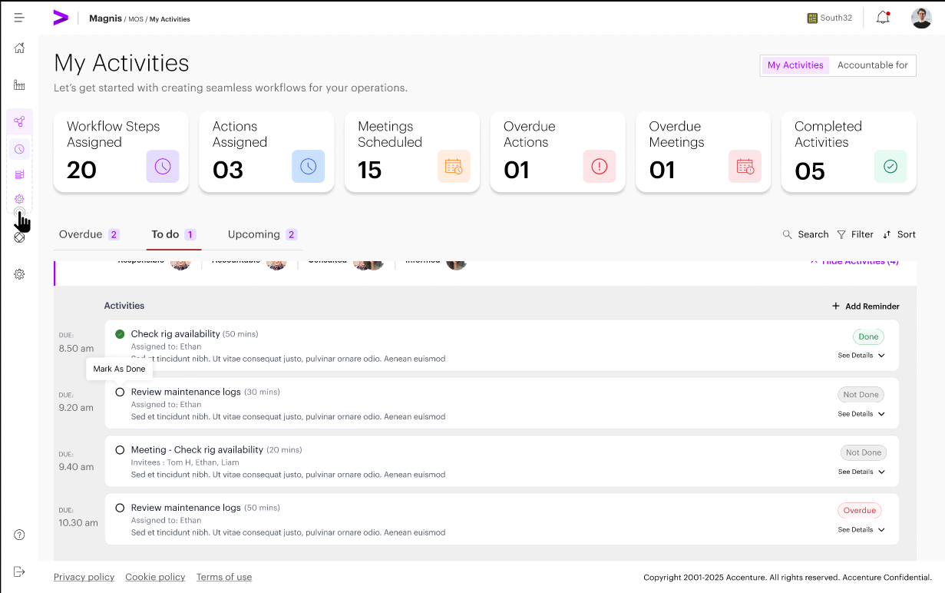
- Activity Title and Description: Each activity includes a clear name and a brief description, providing users with an immediate understanding of the activity's purpose and requirements.
- Activity Type: Activities are categorized as Action, Meeting, Approvals allowing for appropriate handling and differentiation within the workflow.
- Action: Tasks or items that require direct execution or completion by users.
- Meeting: Scheduled discussions or collaborative sessions that involve participants coming together, either virtually or in person.
- Approval: Activities that necessitate review and authorization, ensuring that certain steps are formally validated before proceeding.
- Due Time: The scheduled deadline or time for each activity is specified, enabling users to manage and prioritize time-sensitive tasks efficiently.
- Current Status: Activity status shall be displayed as Done or Not Done. Where applicable, the system shall display additional state indicators as separate pill badges adjacent to the status pill, including Overdue and Waiting Dependency.
- Dependency Indicator: Activities may be linked to dependencies, which are clearly indicated to ensure that users are aware of prerequisite actions that must be completed before proceeding.
  - If an activity or workflow step has no configured dependencies, the dependency status indicator shall not be displayed in:
  - Activity cards
  - Step tables
  - Exception indicators
  - Dependency indicators shall appear only when at least one dependency exist
- Primary Execution Action: Key actions, such as "Mark as Done," are provided to allow users to directly manage and complete activities within their workflow step context.
- Action Activity Comments -
- The system shall provide a Comment field for each Action activity at runtime (i.e., during execution).
- The Comment field shall support rich text (RTF) and must render clickable URLs (e.g., a pasted link to a document or file location) so that an Approver can follow the link to review supporting material.
- For action activities that require approval, the Comment content shall be visible to the Approver when reviewing the associated approval activity.
- After an action activity is marked Done, the Comment shall be displayed within the completed activity (at the bottom of the activity detail) and remain readable with clickable URLs.
- Once the workflow step is completed, the Comment shall be read-only. The Comment shall become editable again only if the user performs an Undo Completion action for the step (or equivalent uncomplete/reopen behavior).
Note : Updated VD Screens will be placed soon

9. Activity Execution Rules
The following rules govern activity execution within the My Activities page:
- Activities become actionable only when all defined dependencies are marked as done.
Execution Rules
- Users who are tagged as ‘Assigned To’ for an activity have specific permissions and responsibilities within the system.
- Upon completion of the required tasks, Responsible users must mark the activity as completed in the system.
- Add personal actions for self-management
- Additionally, if the activity requires any specific inputs or supporting material as part of its configuration, users shall provide these details in the Action activity Comment field (rich text), including pasting any relevant document/file URLs where applicable.
Dependency Handling
- In cases where an activity is dependent on the completion of other activities, such dependencies are clearly indicated in the system.
- Activities that are blocked by unresolved dependencies are displayed with a status of "Waiting Dependency."
- While an activity is blocked, Responsible users are unable to execute or start the activity.
- Once the necessary dependencies are resolved, the system will automatically update the status of the activity, allowing execution to proceed.
Activity Reassignment Rules
The following rules govern activity reassignment:
- Only Workflow Builder or Client Admin may reassign activities
- Reassignment is allowed only at the activity level, not at the workflow or step level
- The new assignee must be a valid user within the same client instance
- Reassignment does not alter the workflow structure or RACI assignments
Workflow Builder can:
- Modify workflow steps
- Change RACI assignments
- Bypass defined dependencies
Note : Updated VD Screens will be placed soon

10. Approval of Activities
Actions Performed by Approvers
- Users who are assigned the Assignment type of Approver have the authority to take specific actions on workflow activities.
- Approvers can formally approve an activity, thereby allowing it to move forward within the workflow. I
- f an Approver decides to reject an activity, they are required to provide a comment explaining the reason for the rejection. This comment is required so everyone understands why the decision was made.
Approval Status Handling
- A workflow step may have multiple Responsible (R) users, each with their own set of assigned activities to execute. The system shall allow Responsible users to continue executing their assigned activities in parallel; the step shall remain Incomplete until all required activities for the step (including any required approval activities) are completed.
- If an activity following an approval activity is configured as dependent on that approval, it shall remain Blocked until the approval is completed; activities that are not configured as dependent on the approval may proceed as normal.
- The current approval status for each workflow step is made visible in both the "My Activities" and "Accountable For" views, providing transparency and easy access to status information for all relevant users.

11. Rejection and Resubmission
Rejection Handling
- Workflow Step Blocking: When an activity is rejected, only the specific workflow step that received the rejection is blocked. Other workflow steps are not affected by this action.
- Dependent Steps: Any steps that depend on the rejected step will remain blocked. These dependent steps can only proceed once the rejected step has been re-approved.
- Visibility of Rejection Comments: All comments associated with the rejection decision are made visible to the user responsible for the rejected activity. This ensures transparency and provides clear guidance for resubmission.
Resubmission
- Activity Update and Resubmission: The responsible user has the ability to modify the rejected activity according to the feedback provided and submit the updated activity again for approval.
- New Approval Cycle: Each time the activity is resubmitted, a brand new approval cycle is initiated, distinct from previous approval attempts.
- Approval History Retention: The system retains the full history of all approval and rejection actions related to the activity. This comprehensive audit trail supports traceability and accountability.

12. Due Dates, Duration and Progress of Activities
Duration and Due Date Logic
- The duration of an activity specifies the expected amount of effort required to complete it.
- The due date/time for an activity is determined by combining its start time with the assigned duration.
- If either the duration or the due date is updated, the system will automatically recalculate the other value to ensure consistency and accuracy in scheduling.
Progress Calculation
- Workflow progress is measured based on the number of activities that have been completed.
- Approval activities are counted toward the overall progress only after they have been approved, ensuring that only finalized tasks contribute to workflow advancement.
Note : Updated VD Screens will be placed soon

13. Notifications and Alerts
The system is designed to generate notifications to keep users informed and prompt timely actions. Notifications are triggered in the following scenarios:
- When a new activity is assigned to a user, the system will send a notification to ensure the assignee is aware of their new responsibility.
- If there are approvals pending action, users will receive notifications prompting them to review and complete the required approval tasks.
- For activities that have become overdue, notifications will be generated to alert users about the missed deadlines and encourage corrective action.
- For activities that are approved, the user will be notified on the same via email
- In cases where activities are rejected or require resubmission, notifications will be sent to inform users of the rejection and the need to resubmit the activity for approval.
Notifications are typically delivered through email, ensuring that recipients receive timely updates regarding their workflow activities and approvals.

